**ASP.NET CA Project**

**Project Specifications**

Create a Shopping Cart web application using ASP.NET for this CA project.

You can assume that the users who are purchasing have already registered with your system. You just need to provision a login screen for the user to map their activities to entries in your database.

The Login screen should look like this. Remember to perform proper validation on users’ inputs and display appropriate error messages.

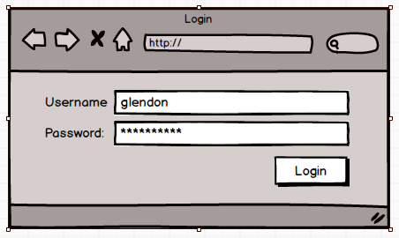

Figure 1:Login

Once logged in, the user will be brought to the Gallery page (Figure 2) to purchase. (note that you need to replace the image-placeholders with actual images.)

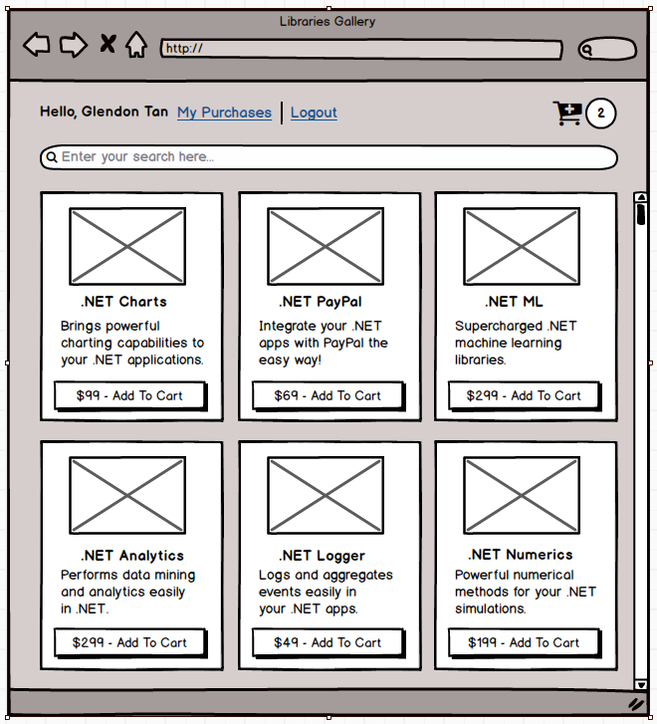

Figure 2: Gallery page

Display the user’s name on the left and a link for him to logout of your system.

There should be a Search bar for users to search for the products he is looking for. Once he hit *Enter*, display the list of products that satisfy his Search string (Figure 3). Once he has cleared the Search bar, list all the products again.

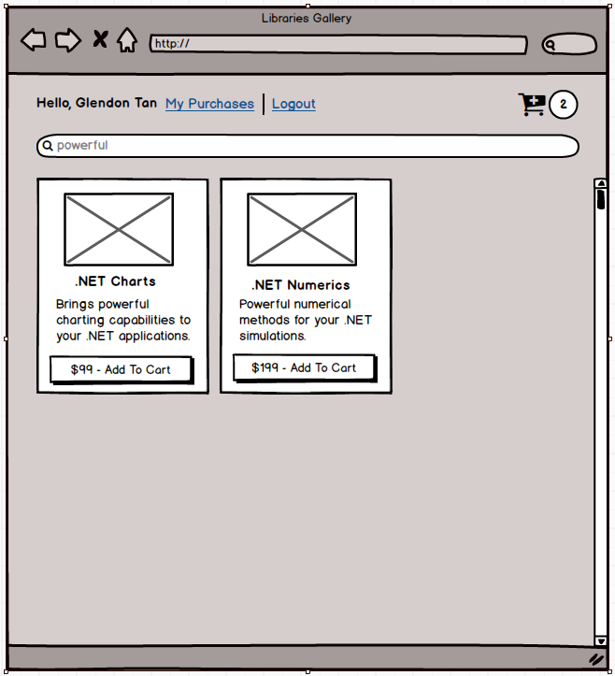

Figure 3: Search

When the user clicked on the “Add To Cart” button, increment the number beside the Cart icon. If the Cart is currently empty and he clicked on the same item twice, the number besides the Cart icon should be 2.

When he clicks on the Cart icon, display the products as shown in Figure 4.

Allow him to change the quantity of each of his selected product and re-compute the Total amount on the top right. If he clicks Continue Shopping, brings him to the Gallery page (Figure 2).

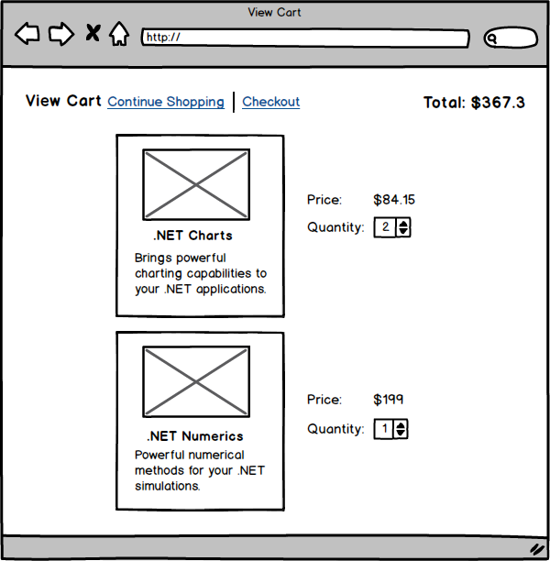

Figure 4: View Cart

If he clicks on Checkout, we assume that the purchase has been successful and brings him to My Purchases pages (Figure 5). Each purchased product will have a unique activation code. If the user has purchased multiple copies of a product, he would have multiple activation codes. Display multiple activation codes with a combo box.

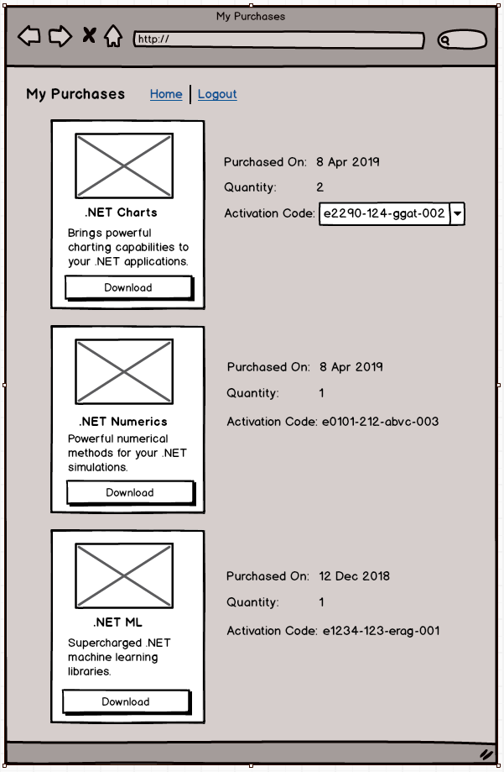

Figure 5: My Purchases

There can be occasions where users are directed directly to the Gallery page (e.g. via a bookmark). We want to allow these users to place items on the cart but before they can check-out, we need to get them to. Once login is successful, we would complete the purchase (we need to remember what they have placed in their carts).

In summary, the core functionalities involve:

1. Login / Logout
2. Browse
3. Search
4. Cart
5. Activation Codes Management
6. Purchase History

The total mark for this CA is **20 marks** and contributes 20% to Paper 2 in the Term 1 exam.

**Submission**

1. Please work in your assigned team for the project.
2. The **deliverable** for this CA is a **single zipped file** that consists of:
3. ASP.NET Project
4. Video Demo (try to keep it with 10-mins)
5. You will be assessed based on the following criteria:
   1. Number of completed features
   2. Neat and functional user-interface
   3. Clean code and sensible design
   4. Clear and audible video demo
6. Refer to assignment due date published on Canvas.
7. Each team should only have ONE submission. Please name your submission with your team’s name. For example, **if you are Team 1**, then your submission would be **Team1.zip**.
8. The submission date for this CA can be found on Canvas.